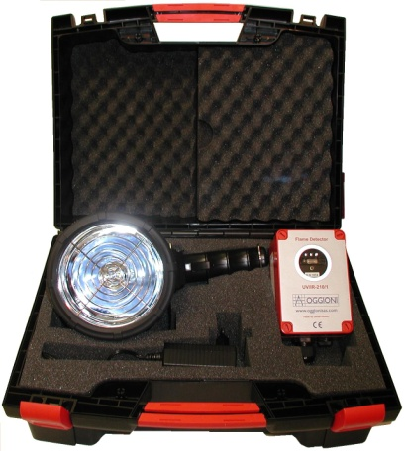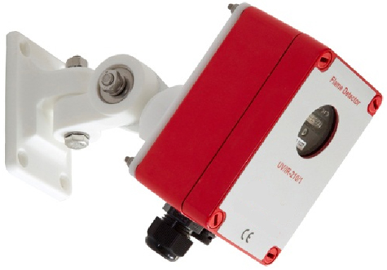

UV/IR Flame Detectors

The OGGIONI UV/IR-210/1 UV/IR flame detector is a combination of a UV- and IR- flame detector which utilizes a microprocessor for sophisticated electronic signal analysis. The IR part of the flame detector has an additional alarm criterion: the analysis of the flame flicker-frequency. The UV and the IR sensor must both exceed their alarm threshold to initiate a fire alarm. The UV/IR flame detector has a good false alarms rejection since the UV and the IR sensor do not share false alarm sources. The UV/IR-210/1 flame detector can thus be applied in areas where single UV or IR flame detectors could potentially cause false and/or unwanted alarms.
The applications in which the UV/IR-210/1 flame detector can be used are:
- Hydrocarbons storage and processing including tank farms
- Hydrogen storage and processing
- Chemical storages, fuels, paint and solvent storage
- Oil and Gas pipe line and pumping stations
- Fuel service stations
- Engine rooms
- Monitoring of machinery
- Aircraft hangars
- Car, bus, tram and train parking’s
- Paint spray booth’s
- Recycling and waste processing plants
- Electric power transformers
- Atriums
- Bio gas setups and stables
Features
- Monitors higher hydrocarbons flames (wood, paper, petrol) but also hydrogen and lower hydrocarbons such as methanol and methane.
- Good resistance against the influences of:
- direct and reflected sun light.
- artificial light, such as fluorescent tubes and glass covered halogen lamps.
- arcs and electric discharges (static or from e.g. electric motors).
- the radiation from electric welding provided that the electric welding takes place at a distance more than 3 meters from the flame detector (a welding rod contains organic compounds which show flame phenomena).
- Less suitable for very smoky fires. This inhibitor of both the UV-sensor and the IR-sensor affects the flame detector performance.
- Automatic Sensor Test (Built-in Self-Test) which monitors the sensors and the electronics of the flame detector for its proper operation.
- DIP-switches to set the sensitivity and latching/non-latching alarm relay outputs to adjust the flame detector to the application (not active in EN54-10 models).
Benefits
- Rugged UV sensor and IR sensor make the detector suitable for virtually all fire types.
- Sophisticated software enhances the reliability and availability of the detector.
- Design of the housing and the swivel mount avoid mounting errors with regards to grounding.
- Automatic Sensor Test (Built-in Self-Test) enhances the reliability and availability of the flame detector.
- A Pressure Compensating Element avoids additional cost of maintenance caused by moisture build up and increases the life time.
- Non-sparking design enhances the reliability and the availability and with a reasonable add on price for an ATEX declaration it is suitable for use in zone 2/22.
- Warranty: whichever comes first: 36 months after installation or 42 months after supply.

Specifications
Flame Detector UV/IR-210/1
Power | 12-24 Vdc (10-28 Vdc)
Current normal | 25 mA at 24 Vdc
Current in alarm, at 24 Vdc | +/- 75 mA at 24 Vdc
Startup time | <10 sec
Alarm output setting | Selectable LEDs and relays latching/non latching, factory and EN54-10 setting: latching
Connectability | - a fire control panel by means of end of line (EOL) and alarm resistor (current increase).  - a device that can take relay outputs  - a PLC with a 0-20 mA input
End of line and alarm resistor | To be adjusted to the fire control panel, free terminals dedicated for the resistors are available.  Remark: the value of the alarm- and EOL resistor combination must be >500 Ohm.
Relay outputs:  - alarm relay  - fault relay | De-energized during normal operation, no alarm, SPDT, 30 Vdc – 2 A, 60 W  Energized during normal operation, no fault, SPDT, 30 Vdc – 2 A, 60 W
Current output | Standard available 0-20 mA (stepped, sinking, non-isolated)
Alarm response time | >8 s, <30 s. See appendices
Cone of vision | 90⁰
Housing | Glass Reinforced Polyester (GRP)
Ingress protection | IP65
Temperature (operating) | -25⁰ C tot +70⁰ C (-13⁰ F tot +158⁰ F)
Automatic and manual Self-Test | Automatic Sensor Test (Built in Self Test) and manual sensor self-test
Sensitivity settings | Selectable: very high, high, medium, low (factory setting: high, standard for EN54-10 certified models)
Dimensions | 125 x 80 x 57 mm (4.9 x 3.15 x 2.25 inch)
Weight | 492 gram (1.09 lbs)
Cable gland | M20 (cable conduit diameter 5.5-13 mm in two steps 5.5-8 mm and 8-13 mm)
Pressure compensating Element | PCE (Pressure Compensating Element) avoids moisture build up in the detector housing, caused by pressures differences as a consequence of temperature fluctuations.
Terminals | Suitable for massive cores 0.6 to 1.5 mm² (24 to 16 AWG)
CE marking | See www.oggionisas.com for Declaration(s) of Conformity
EN54-10 Certificate | Only for model UV/IR-210/1C and UV/IR-210/1CZ
ATEX Declaration of Conformity | Only for model UV/IR-210/1Z and UV/IR-210/1CZ, suitable for use in ATEX zone 2/22
FM3260 approval | Only for model UV/IR-210/1F and UV/IR-210/1FN, (pending)
FM3611 approval | Only for model UV/IR-210/1FN, suitable for use in Class I and II, Div 2. Class III, Div 1 and 2 (pending)
Optional Swivel MountSM21
Material | POM
Weight | 325 gram (0.7 lbs)

Options:
Catalog Code | Part # | Description
UV/IR-210/1 | SW1096 | UV/IR flame detector, with variable sensitivity settings and selectable latching/unlatching alarm
UV/IR-210/1C | SW1097 | UV/IR flame detector, one sensitivity and latching alarm, EN54-10 certificate
UV/IR-210/1Z | SW1105 | UV/IR flame detector, with variable sensitivity settings and selectable latching/unlatching alarm, suitable for ATEX zone 2/22
UV/IR-210/1CZ | SW1106 | UV/IR flame detector, one sensitivity and latching alarm, EN54-10 certificate, suitable for ATEX zone 2/22
UV/IR-210/1F | SW…… | UV/IR flame detector, two sensitivity settings and selectable latching/ non latching alarm, FM3260 approval (pending)
UV/IR-210/1FN | SW…… | UV/IR flame detector, two sensitivity settings and selectable latching/ non latching alarm, FM3260 approval (pending) and FM3611 approval (pending)
SM21 | SW1098 | SM21 swivel mount
T-229/4P | SW1067 | T-229/4P universal UV/IR test lamp for flame detectors, incl. universal charger
TC-229/4P | SW1082 | TC-229/4P universal UV/IR test lamp for flame detectors, incl. universal charger and carrying case
C-430/1 | SW1069 | C-430/1 carrying case for T-229/4P test lamp
UE-458/2 | SW1020 | UE-458/2 Mini Fire Card, with 11 pins relay base
JB1 | SW1100 | At request: Junction box with 2 glands, for address unit (excl. address-unit)
JB2 | SW1101 | At request: Junction box with 2 glands, incl. sourcing 0-20 mA output and bus-protocols
CLN | SW1102 | Microfiber cleaning cloth for flame detector windows, set of 10 pieces

